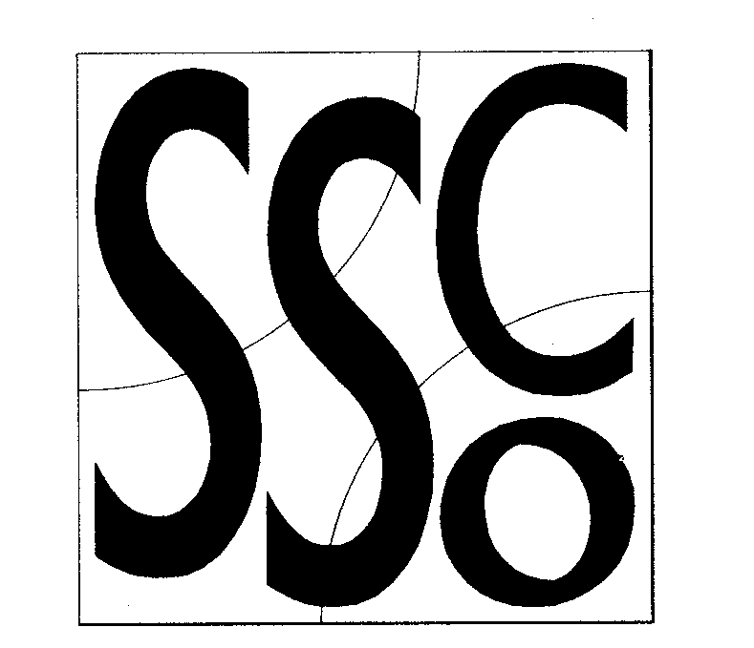

Teaching Points
Cover running technique
Look out for other children when running

Treasure Hunt
MULTI SKILL CARDS



Classification
Small team games

Equipment
Large hoops
Any treasure items

Differentiation
Easier: just bring the treasure back

Harder: Throw the treasure back to their hoop

Activity/ Key Points

- Need a large area, roughly 30m x 30m.
- Spread large hoops around the playground
- Divide class into equal numbers and give each group a hoop to stand by
- Give each group 3 or 4 objects to go inside their hoop
- On the command 1 member of the group must run to someone else’s hoop and ‘pinch’ only 1 piece of treasure and take it back to their hoop.
- Once the first person is back the next pupil goes and so on.
- The winner is the team with the most treasure collected

X x

X x x

X

X x x x

X x

X x

x

